Bolton Update

Declaration of Ousel Nest Quarry at Bromley Cross as a Local Nature Reserve was completed towards the end of November 2013. This was part of the continuing programme of enhancing and expanding the nature reserve network across Bolton. Site name posts made from re-cycled plastic have been erected at entrances to the reserve to help raise the profile of the site. Name posts have also been installed at Eagley Valley LNR and Upper Bradshaw Valley LNR on the edge of West Pennine Moors.

Some improvement works have been undertaken at Ousel Nest Quarry LNR with repairs to the car park driveway, filling pot holes and installing speed restrictions. Fence repair and refurbishment of the path to the quarry floor was completed by Mojo Trust, who provides training and experience to the long term unemployed. Bolton Conservation Volunteers undertook hedge laying on the new reserve and British Mountaineering Council volunteers have cleared sections of quarry wall face for climber training.

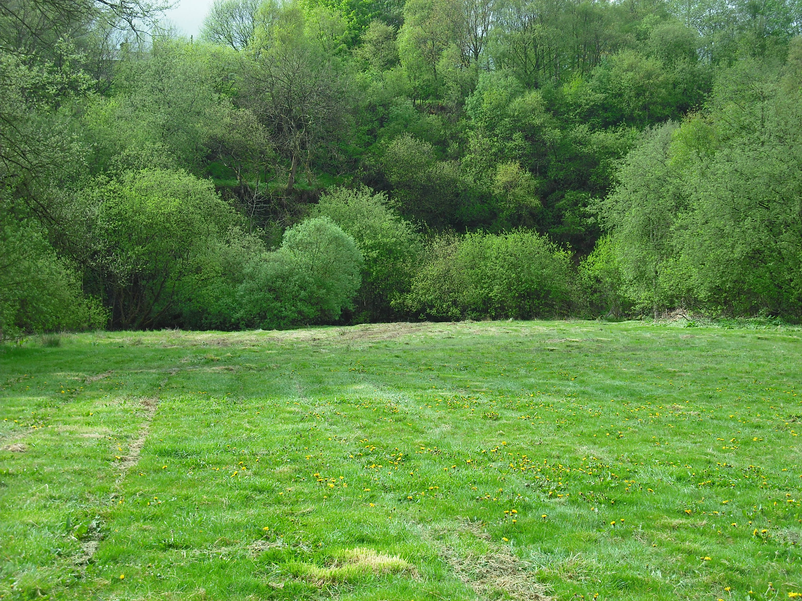

Quarry Floor
Ousel Nest
Quarry LNR

Upper Bradshaw Valley LNR is another gateway to the West Pennine Moors, south of Jumbles Reservoir. Our partner United Utilities PLC have undertaken repair work to weirs which protect sewer pipe crossings across Bradshaw Brook. Ground restoration is ongoing to repair minor damage caused by the work. Replacement of two kissing gates is planned to provide disable access via gates which allow mobility access by RADAR key. This will help less able bodied visitors to enjoy the flatter parts of the reserve avoiding steps and slopes.

The exotic weed Japanese Knotweed is again being herbicide treated, targeting persistent plants that survived previous treatments. This will aid our native flora and wildlife. Plans are underway to establish a conservation grazing partnership with a local farmer to return the grassland areas to traditional management practices. Our wildlife has adjusted to the traditional agricultural management of the last few centuries and a return to these methods should encourage return of grassland flora and the bees and butterflies that are associated with grassland meadows.

